**Class Activity – Lesson 17**

1. Did you attend class today (8 pts)
2. Were you on time to class today (4 pts)?
3. **Confidence Interval -** An October 2008 poll conducted by the Gallup Organization, 705 of 1200 randomly selected adults aged 18 years old or older stated they think the government should make partial birth abortions illegal, except in cases necessary to save the life of the mother?
   1. (1 pt.) Find the proportion (point estimate) of those who feel we should make partial birth abortions illegal using .

**0.588**

* 1. (1 pt.) Check requirements in constructing a confidence interval for this data. What do you assume based on your findings?

$$n*\hat{p}=1200* 0.588=705≥10$$

$$n*\left(1-\hat{p}\right)=1200*\left(1-0.588\right)=495≥10$$

**We can assume that the requirement is met, because both requirement results are greater than 10; therefore, the distribution of a sample proportion is normal.**

* 1. (1 pt.) Determine the margin of error for this confidence interval (with the level of confidence being 95%).

**0.588 – 0.560 = 0.028**

**Or**

**(0.615-0.560)/2 = 0.028**

* 1. (1 pt.) Construct and interpret the 95% confidence interval for the proportion of those who are in favor of making partial birth abortions illegal.

**We are 95% confident that the true proportion of those making partial birth abortions illegal is between 0.560 and 0.615**

**Test of Hypothesis** – Now you are interested in testing a claim that the percentage is different than 60% of all adults, 18 and older, are in favor of making partial birth abortions illegal. **Use the same information as above** and use a level of significance of α=0.05.

* 1. (1 pt.) Check the requirements for doing this hypothesis test. What do you assume based on your findings?

$$n*p_{o}=1200* 0.60=720≥10$$

$$n*\left(1-p_{o}\right)=1200*\left(1-0.60\right)=480≥10$$

**The requirement is met.**

**We assume that the distribution of the sample proportion (p-hat) is normal.**

* 1. (1 pt.) Show the descriptive statistics for this analysis.

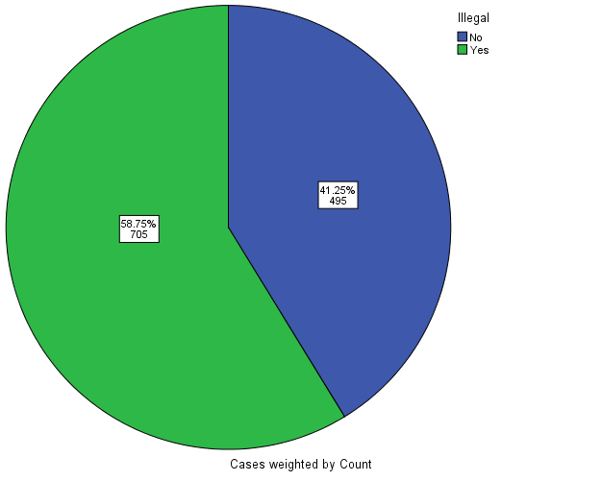

**p-hat=0.588**

**Standard Deviation=0.014**

* 1. (1 pt.) State the null and alternative hypotheses

**Ho: p=0.60 Ha:p≠0.60**

* 1. (1 pt.) Compute the Test Statistic

**Z=-0.884**

* 1. (1 pt.) Determine P-Value based on Test Statistic. Sketch your P-value on the normal distribution curve with the Test statistic labeled.

**0.377**

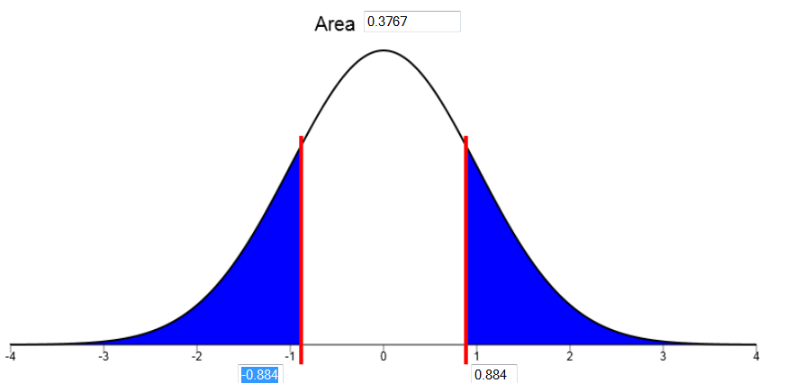

* 1. (1 pt.) What decision do you make about the null hypothesis based on the decision rule?

**P-value is greater than alpha; therefore, we do not reject the null hypothesis.**

* 1. (1 pt.) State your conclusions in “layman’s terms”.

**We have insufficient evidence to say that the true proportion of Americans in favor of illegalizing partial birth abortions is different than 0.60.**